Photo/Video Consent and Release Form
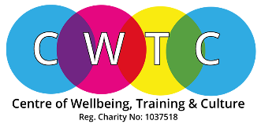
- Without expectation of compensation or other remuneration, now or in the future, I hereby give my consent to CWTC to use my image and likeness and/or any interview statements from me in its course verification, publications, advertising or other media activities (including the Internet). This consent includes, but is not limited to:

(a) Permission to interview, film, photograph, tape, or otherwise make a video reproduction of me and/or record my voice;
(b) Permission to use my name; and
(c) Permission to use quotes from the interview(s) (or excerpts of such quotes), the film, photograph(s), tape(s) or reproduction(s) of me, and/or recording of my voice, in part or in whole, in its course verification, publications, in newspapers, magazines and other print media, on television, radio and electronic media (including the Internet), and/or in mailings for educational and awareness.
- I understand that images/recordings on websites can be viewed throughout the world and not just in the United Kingdom and that some overseas countries may not provide the same level of protection to the rights of individuals as EU/UK legislation provides.

I understand that some images or recordings may or may not be kept permanently once they are published.
I have read and understand the conditions and consent to my images/recordings being used as described.
- This consent is given in perpetuity and does not require prior approval by me.

Print Name:
Unit Title:
Organisation (if any):
Signature:
Date:

CWTV is committed to processing information in accordance with the General Data Protection Regulation (GDPR). The personal data collected on this form will be held securely and will only be used for administrative purposes.
Thank you for your time.

Please submit with completed Assignments.

