Short Course Evaluation Form
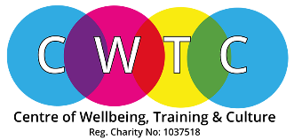
In order to maintain our high standard of the courses/units, we would be grateful if you could complete this form. We take notes of your comments as they help us to continue to improve our services.

Name: _________________________________ Date: _____________

Unit Title: _______________________________ Level: _____________

Venue (if applicable): _________________________________________________

Please rate the following:

Poor Fair Good Excellent N/A
Tutor(s) □ □ □ □ □
Content □ □ □ □ □
1. How would you describe the level of the session?
□ Too Simple □ Just Right □ Too Complex

2. Did the session meet your needs/expectations?
□ Fully Met □ Partially Met □ Not Met

3. Would you recommend this session to a friend?
□ Yes □ No

4. Which skills have you learnt?
□ More confidence □ Skill enhancement □ Communication skills
□ Team Working □ Cultural Awareness □ Sharing skills
□ Motivation □ Feel better □ Progression to higher level
□ Better understanding of subject
□ Other (please state): ________________________________________________

5. What would you like to do next?
□ Another course/unit □ Further Training □ Work Placement
□ Volunteering □ Look for a job □ Join Advisory Board
□ Other (Please state)

6. Was the Venue suitable (if applicable)?
□ Fully suitable □ Partially suitable □ Not suitable □ Not applicable

7. Please use this space for any further comments.

Signed: _________________________ Date: ____________

Thank you for your time.

Please submit with completed Assignments.

