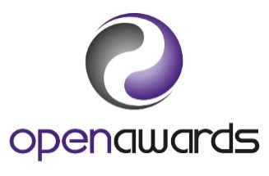
Learner Authentication Statement

The evidence you submit must belong to you, have been produced by you and must be current.

Learner Name:
Tutor (Name):
if different from Assessor
Assessor (Name):
Qualification and/or Unit(s): | Please list:
 |  | Please tick ()
I confirm that the work/evidence I have submitted is my own work and has been created by me
I understand that my results may be invalidated if I have submitted evidence that does not belong to me
All evidence submitted towards my Open Awards qualification is current

Learner’s Signature:
Date:

This statement should be submitted by the Learner along with their evidence and confirmed by the Learner’s Assessor, within their assessment feedback.

All information provided on this form will be held securely on our database and only used for the purposes provided. Full details on how we use and protect your data are available in our Privacy Notice.
Open Awards tries to meet the highest standards when collecting and using personal information. Customers are encouraged to email info@openawards.org.uk if you believe any data to be incorrect, unfair, misleading or inappropriate.

